State Required Qualifications for a Scribe IEP Accommodation

Student Name_______________________
Submit this form and documented evidence along with the IEP of each student who qualifies for a scribe. (This checklist need not be completed for those students who have already had their annual review prior to March 10th 2012).

Qualification |  | Example Evidence Student Qualifies | Documented Evidence (attached samples / documentation)
 | Cannot Physically Write | Medical documentation of physical disability
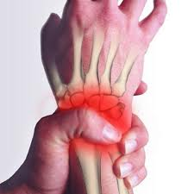 | Reduced stamina due to Pain | Medical documentation of physical disability
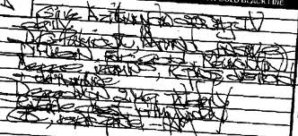 | Undecipherable Handwriting that is completely illegible | O.T. Report evidencing lower extreme letter formation skills
 | Documented Processing Disability in Writing Content (Not Mechanics) | ETR Report evidencing consistent (not variable) written expression deficits related to inability to process content such as dysgraphia, must require scribe support in most daily assignments
** A scribe CANNOT be provided to accommodate for difficulty attending.
** Scribe accommodations must be used regularly in the classroom (not just for testing).

